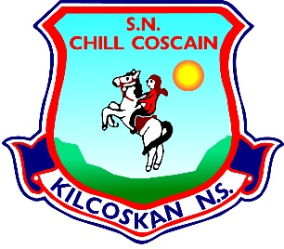
KILCOSKAN NATIONAL SCHOOL 2022 - 2023
Kilcoskan National School, Kilcoskan, The Ward, Co Dublin Ph: 01 8351508
www.kilcoskan.com

First Class Booklist - Bookhaven Code: u1kt1c

Class books to be purchased by parents
English: Starlight First Class Skills Book Code: 9781780909257

Handwriting: Ready to Write C1 Cursive (First Class) Code: 9781845364731

Spelling: Spellbound 1 (First Class) – CJ Fallon Code: 9780714416359

Maths: Cracking Maths Pupils Book (First Class) - Gill and MacMillan
Code: 9780717154197
New Wave Mental Maths (First Class) Code: 9781920962395
Maths Table Book – Code: 9780714410425

Gaeilge: Bua Na Cainte 1 (First Class) Code: 9781845365479

SESE: Small World History, Geography & Science (Second Class)
Code: 9780714420837 * First class are using a second class book this year

- Please ensure all books and stationery are clearly labelled for the first day of school.
- Please ensure ALL uniform items, tracksuits, coats, hats etc are clearly labelled.
- Please ensure all school bags, lunch boxes and beakers are clearly labelled.

