Kilcoskan NS

Term 1 Aug-Dec 2023
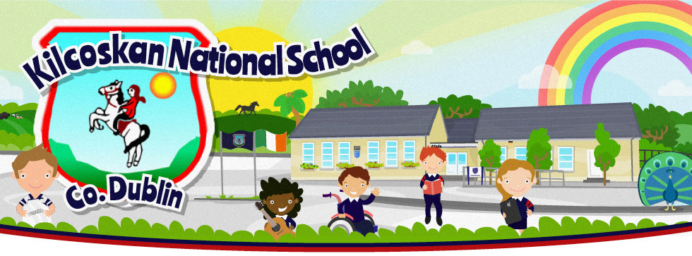
Hi everyone !!

We hope you had a lovely Christmas !!
We have been very busy in Term 1 and wanted to tell you all about what we were doing .

Each class spent time talking about what they did during term 1 and then helped their teachers type it up in a document so we all can read about it .

Just for your information we had WOW ( Walk on Wednesday ) days in Sept and Oct and will resume these mornings in early February- weather permitting .
There are still a small number of families who haven’t paid their school fees and I will be ringing them individually next week regarding this .
Nigel continues doing GAA on Wednesdays and we had Olympic Handball for 3rd-6th class in term 1 also . We are going to be doing some hurling coaching for some classes also , provided by Wild Geese GAA club and will provide further details shortly .
We are lucky to have secured the services of two Play Therapists who will work with some of our children in the school in Term 2 .
Please respect other drivers around the school car park and out on the road beside the school – you will have seen an increased Garda presence in Term 1 and this is as a result of safety concerns brought to my attention by parents within the school and local residents who have no connection with the school . We hope that the ramps will slow down the general public .
As always a big thank you to Rachel one of the the hardest working secretaries in Ireland and to John Rooney who does great maintenance work around the school !!
Finally a big thank you to all the staff who have worked just as hard as the children in our school to provide a stable , caring environment for our children – we are lucky to have people who will always go the extra mile for the school

Best wishes

Paddy Christie

Junior and Senior Infants Newsletter Term 1
School started on the 30th of August and we were all really excited to start school and meet all of our new friends. We had lots of fun in the first term learning new things and playing with our friends. We learned lots of different Early Mathematic Skills such as counting and sorting skills. We also learned Social Skills such as being good at sharing and communicating our feelings with others. In Science we learned about the seasons and animals, and also the solar system, and one of the highlights of the terms was when some boys and girls from 5th and 6th class came into our class with Mr. Christie to do a Science Show for us.
We were the first class to win the Paper Clip competition this year for having the best line in the school. As our prize we chose to have a pyjama day and have a movie party. His happened to fall on the same day as the Science Show. Our favourites parts of the Science Show were;
The Rocket outside
The Static Electricity experiment with the balloon and Hunters Hair
The Karate Chop by Mr. Christie!
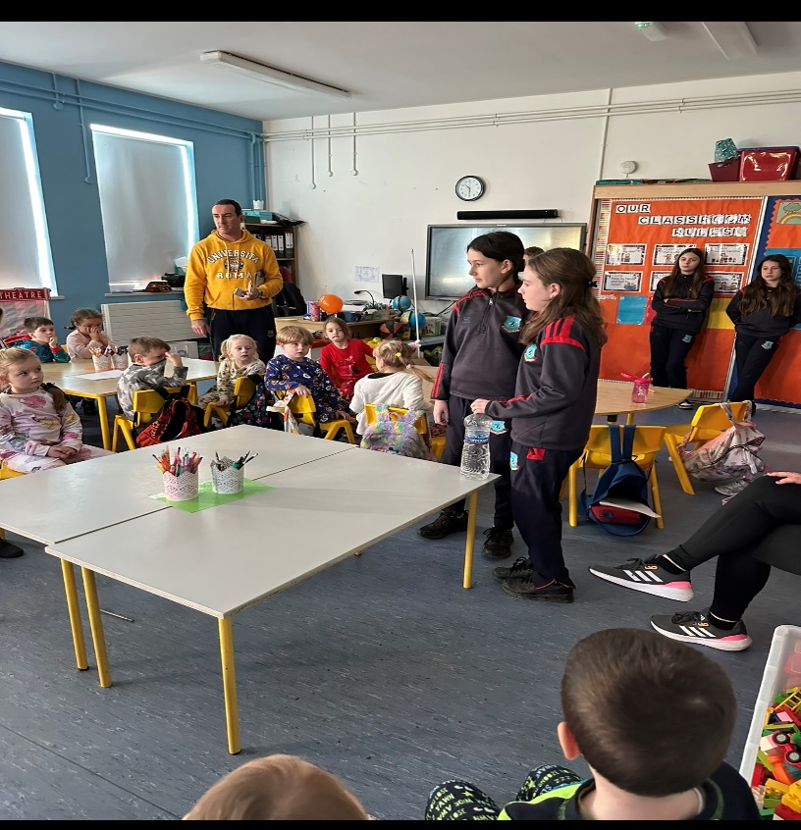

We also had a visit from Micheal Moylan this term and he told us some very funny stories. We really enjoyed his visit!

We did a lot of art this term. We explored what we could do with paint, we made lots of different pictures, at Christmas we made cards for our friends and also some reindeer. But, our biggest art piece was the Harvest Fair sheet. We all worked together to create our pumpkin patch and we were really proud of how it turned out!

The build up to Christmas was probably the busiest and most exciting part of term 1.
We were very busy practicing our songs for the Christmas Concert which went very well! We went to The Helix in DCU to see the pantomime ‘Treasure Island’ this was most of the children’s favourite memory from the school year so far. We had a great day heading off on the bus with our friends and watching the show.
Our elf Snowy was constantly playing tricks on us such as, stealing from our prize box, eating Teacher Daniel’s sweets and wrapping the Christmas tree in toilet paper!!!
We also had a very special video message from Santa Claus himself which the class were really amazed by!
We have also been working so hard all year with or healthy eating, this has been helped by the Food Dudes! We really enjoyed the food they sent us and everyone was so brave to try all of the different types of fruit and vegetables.

1st & 2nd class: Term 1 Eoin Kelleher
During our first term in 1st & 2nd class here in Kilcoskan we did lots of very exciting things!
Here is a list of just a few of them:
In September we celebrated the Harvest Festival. We all dressed up in our favorite Harvest attire and did dancing and sang songs all harvest related - ye haw!
Our Mums, Dads, brothers, sisters and Grandparents were all invited to attend. It was a great celebration.
In October we learned about the history of Halloween and the importance of Fire Safety.
We had a dress up day and a spooky Haunted House.
In November we elected the new Students Council and engaged in lots of interesting Scientific experiments with Mr Christie during Science week.
After school clubs such as Lego and Christmas crafts commenced too. It was a very busy month!
In December we participated in the Food Dudes programme. It was only for one week but we got to taste lots of healthy fruit and veg!
We also got to go swimming in the pool in Finglas.
We went to Charlestown shopping Center and Newpark Nursing Home to sing Christmas Carols to spread joy and happiness.
We also got to sing carols for our family members in the annual concert in the Cooquay Lodge.
We started term two to learn the wonderful news that Teacher Eoin and his wife Sinead became parents to their beautiful baby girl Orla.

Teacher Trish - Third and Fourth Class

It was a very busy term for 3rd and 4th Class. Everybody settled in
really well and we are enjoying ourselves at school.
Here are some of the wonderful activities we’ve loved this term.

Everybody in 3rd and 4th class had a chance to be a VIP student
for the day in September.

- A lady visited from Heritage Ireland to teach us about the
plants and animals in our school grounds.
-We celebrated the Harvest Festival; great fun was had by all.
The cakes were delicious!
- Halloween time was lots of fun we had a Haunted House and a
party. Everybody dressed up. The costumes were amazing.
- We had a teaching student from Marino College. We really
liked her, and she taught us loads. We also had some wonderful
past pupils back to help us in our classroom.
- We visited the Recreate Centre in Ballymun. We learnt lots
about space and we got to build our own space rockets.
- Michael Moylan from Heritage Ireland came to the school. As
always, he was very funny and taught us lots about World War
1 and World War 2. He had wonderful artifacts with him.
- We went swimming. Everybody enjoyed this!
- Teachers from schools around Europe visited our class. They
spoke to us about school life in their own countries this was
really interesting.
- The Student Council elections took place. Well done to all
students who put themselves forward and a big Congratulations
to Sarah, Daniel, Grace and Mason our class Student Council
members. A special mention to Evie G who represents our two
smaller classes.

- We were delighted to win the ‘Line’ competition and we
celebrated with a pizza party.
- We participated in an Olympic handball tournament after
training with our coach Caroline for a few weeks. The girls’
team did very well and the boys team won their final.
- The Christmas school concert in the Coolquay Lodge went really
well and all our hard work paid off.
- A big highlight of the year was our trip to the pantomime in
the Helix. We watched Treasure Island. It was brilliant.
- June and Deirdre treated the whole school to breakfast!
- Santa visited with selection boxes for everyone.
- We enjoyed making our sock snowmen.

There has been lots of learning and fun in our classroom this term.
From our very first day to now, we’ve enjoyed every moment!!!

Teacher Amy Fisher – Fifth & Sixth Class

- We got to a league final in an Olympic Handball tournament in Sports Link.
- We had a Harvest Fair in October. Fifth and Sixth class taught a dance to the rest of the school and organised and ran different stalls on the day.
- We looked at pop art, particularly Andy Warhol’s work.
- We learned all about Africa.
- We learned about The Amazon Rainforest. We focused on the effects of deforestation on its animals and people.
- We also went swimming and did some gardening.
- We also looked at the Civil Rights Movement in the 60s.
- In November, we had our Student Council Elections- Jack, Nicole, Rayne and Daire are all on the student council this year.
- Christmas in our class- We did Kris Kindle, we did our christmas concert, we went to a panto in the Helix. Our choir went to Charlestown Shopping Centre and Newpark Nursing Home.

Term 1 Newsletter Junior Small Class 2023/2024 Teacher Ava

● We had a very busy first term in our class. At the beginning of the
term we went to The Arc Puddenhill where we visited the soft indoor
play area, the outdoor playground and the petting farm! We had so
much fun!
● We had three weeks of horse riding lessons in Oldtown! It was a
wonderful experience and the class really enjoyed our time there.
● In November we took a trip to IKEA! The class loved visiting the shop
and we stopped by the cafe on the way home.
● We had a very special visit from Santa in December. Our families came
in to visit on the day and it was such a magical experience.
● In December we were learning all about the post office. In class we
learned all about how to send and write letters. We made beautiful
Christmas cards and wrote a message for our parents. We then walked
to the local post box and mailed the card home.
● In term 1 we did lots of cooking and baking. We made lots of nice
treats such as rice crispy buns, ham and cheese toasted sandwiches,
marshmallow squares and mince pies for Christmas.
● Every Thursday we took a trip to the Coolquay Lodge for juice and
biscuits. The children love their weekly trip there. We also took a trip to Brady’s Garage for ice cream

News from Small Class 2: Lorraine

☆ We had great fun going horse riding and to Puddenhill.

☆ We are learning how to use our leap cards and visit the library in Ashbourne every week.

☆ We explored money in Maths and are learning how to use the self service checkout in Tesco when we shop for our weekly baking ingredients.

☆ We loved painting like Michelangelo!

☆ We are learning all about road safety on our weekly walks.

☆ We went to the panto in The Helix and did our Christmas show for our parents.

☆ We had a special visit from Santa.

☆ We are redecorating our quiet room - painting our favourite characters on the walls

We hope you enjoyed our news !!

Don’t forget that a lot of our activities are posted on the school website www.kilcoskan.com

Best Wishes

Paddy Christie
Principal
Kilcoskan NS

