Kilcoskan NS
Newsletter
Term 2 Jan-March 2024
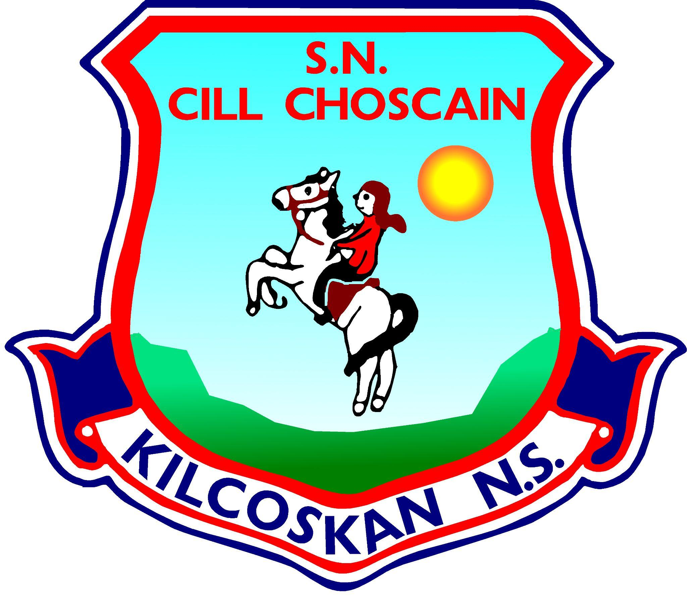

Dear Parents/Guardians,

We hope you are all well and enjoying the start to term 3!!

We wanted to let you know all the good work going on in our school for the last 4 months and each class did their own report about it 😊
The weather has made things difficult for us all since January, but we are still doing all we can in trying conditions!!

Enjoy the read – here’s looking forward to some better weather this term!!

Paddy Christie

Teacher Eoin - 1st and 2nd Class
It’s been a really quick second term…St Patrick’s Day is just over and we’re just
around the corner from Easter! As usual, we’ve been really busy in 1st and 2nd class!

Gordon from Wild Geese GAA Club taught us some fundamental hurling skills
which will hopefully inspire a few future hurlers! Rain, hail or shine, Nigel comes
over to KNS to practise our GAA skills. We’ve also had a student teacher,
Teacher Aoife, visit us each Monday and she’s done a few lovely lessons with us.

We put a lot of work into preparing for our First Holy Confessions which took
place on 4th of March. Fr Richard was, as always, very kind to us. During April
we’ll be putting in even more work to prepare for the main event, First
Communion!

Two weeks ago, we looked at the work engineers do as part of Engineering Week,
and last week we had lots of fun during Seachtain na Gaeilge…we even do a
pretty good rendition of Amhrán na bhFiann!

Throughout the term we’ve been reading our class novel, Ratburger, by David
Walliams…we’re almost finished it, but we have to find out what happens at the
end of the story before we break up for our Easter Holidays!

Teacher Lorraine - Senior Small Class
Teacher Lorraine’s Class have been very busy this term
- We continued using our leap cards and visited the Ashbourne
Library every week.
- We attended a Lego Exhibition! There were lots of amazing
creations including the NASA Space Station, Hogwarts and a
Pet Café! We also got to vote for our favourite display which
was very difficult as they were all fantastic!
- We had fun exploring Engineering Week. We learned all about
Friction and its effects by completing an experiment using a
ramp, racing cars and different materials including bubble
wrap, sandpaper and towels.
- We visited “The Dome” and had lots of fun racing down the
slides and using the soft play area!
- We celebrated Louie’s birthday with a party in class!
- We had a movie day and dressed up as our favourite characters
– Teacher Lorraine and Eoin dressed up as Willy Wonka to
celebrate the new “Wonka” movie.
- We went to “Look Mam No Hands” as a special treat. We have
been learning all about how to read menus and choose what you
want to eat! Seán, Louie and Charlie enjoyed chicken nuggets
and chips. Eoin chose pancakes and said they were “the best
pancakes” he had ever tasted, while Will loved his vanilla
milkshake, chips and nuggets!
- We continued learning about road safety with our weekly
nature walks and visits to the Coolquay Lodge.
Looking forward to more adventures in Term 3!

Teacher Daniel - Junior and Senior Infants Newsletter
We have been very busy since coming back to school after our Christmas
holidays.
We have all progressed massively with our understanding of maths and
phonics and have been busy building, painting, drawing and even baking!
We had Gordon from the Wild Geese GAA Club join us for 3 weeks to teach us
about hurling. Over the course of the 3 weeks Gordon played lots of games and
did fun activities with us using the hurl and sliothar. We really enjoyed
Gordons hurling lessons and hopefully it has inspired a new generation of
hurlers in our school!
One of the highlights of this term has definitely been the After School Club
which ran for 4 consecutive Wednesdays.
On the first week of the After School Club we made Rice Krispie buns, we all
went down to the kitchen and helped Mary melt the chocolate. We then mixed
the chocolate in the bowl with the Rice Krispies and decorated them with mini
eggs, sprinkles and marshmallows.
The second week of the club we made some spring art using crepe paper, and
we cut it and stuck it to make flowers.
The third week of the club we made some chocolate chip cookies which tasted
extremely yummy! We mixed all of the ingredients in the classroom and all
formed our own cookies with the dough and placed them on the baking trays.
We then sent them down to the oven where they cooked while we completed
some art work. Then when they were cool, we got to enjoy one while watching
a movie and took one home also to share with our families.
The final week we completed some more art work and had a little popcorn
party to celebrate our club.
Nigel has continued to develop our football and gross motor skills, while
Teacher Aisling and Teacher Amy have been visiting our class weekly to help us
with Power Hour. We also had Teacher Trish’s class in for engineering week
and they helped us build Rolling Racers using the Kinex sets and rubber bands.
We really enjoyed this lesson and had lots of fun building our cars.

Teacher Amy Fisher – 5th & 6th Class
We have had an eventful year so far in Kilcoskan. Here are just some of the things we got
up to this year!!

Justful January
Early in January, we went to the 3D maker workshop in Blanchardstown Library, where we designed our own phone holders and learnt about 3D printing.
We learned about Martin Luther King, racism and civil rights. The boys participated in an Olympic handball tournament. In history we learned about the great Irish famine and the potato blight that caused it. We continued our long division after Christmas. During this time we had a lovely student teacher named Clara.
For English we learned about narrative writing. As for Irish, we learned about hobbies and how to ask somebody what their favourite hobbies are and how to answer that question. That was our January!!!

Fantastic February
On the first of February, we hosted a movie day with a big raffle with 3 20 euro cinema
vouchers. The girls had a friendly match against St. Mary Queens school. In English we
started our procedural writing where we learned to write recipes about our favourite
meals. Our student teacher Clara left to go to a new school to start her career as a
teacher and so we had a going - away party for her. The sixth class started their work for
their confirmation. The fifth classers helped with the preparation for the library opening.
We began our class economy system where you can earn money from being good or from our classroom jobs which include sweepers, helpers, table cleaners etc. We also started our research on world war 11. That was our fantastic February!

Marvellous March
For the opening of our library, we had a competition in which every pupil designed a poster based on their favourite book. The winners had their posters framed in the library for
that month, and each month the posters are changed.
On the seventh of march the sixth class made their confirmation, and the next day the library officially opened. We also began hurling lessons with coach Gordon from the Wild Geese GAA. During Seachtain na Gaeilge we did lots and lots of activities as Gaeilge such as quizzes, PE, art, and we even watched a movie in Irish!
Finally, the student council organised a YellowDay on the last day before the Easter holidays to raise money for cancer research. I can’t wait to tell you all about the fun stuff that we will get up to in the next term.
By Kate, Ruby, Rayne and Eva.

Teacher Ava’s Junior Small Class
We had a very busy second term in our class. We had some fun trips
to IKEA and Ashbourne playground. In IKEA we visited the café and
had some lovely food after all our shopping. The class loved
exploring in Ashbourne playground.
• We explored lots of different topics this term - we learnt all about
different schools, animals that live under the sea, healthy foods and
all about the Zoo! We read lots of books about these topics and
created lots of different artwork relating to our learning.
• During this term we read the story ‘Jack and the Beanstalk’. We
loved the story so much that we decided to plant and grow our very
own beanstalks in class. Each day we have been watering the plants,
we can’t wait to see how they grow!
• Throughout the term we visited the Coolquay Lodge for some treats
and juice and to Brady’s garage. We loved our trips there and
meeting all the staff who take such great care of us when we visit!
• To celebrate Mother’s Day we made beautiful cards for all our
amazing Mothers. We also made Valentines Day cards for our Moms
and Dads. We then walked to the local post box and mailed our
cards home.
• We did lots of cooking and baking this term such as rice crispy buns
and smoothies!

Teacher Trish – 3rd & 4th Class

This term has been another very busy one.
- We welcomed a new student to our class!
- Big thank you to our Parent’s Association who made us delicious pancakes on Pancake Tuesday.
- We had a visit from teachers from all over Europe we really enjoyed this.
- We celebrated Seachtain na Gaeilge with a quiz and a cinema as gaeilge. We also had a ‘Green Day’ to celebrate all things Irish.
- We are loving our new school library. There are some amazing books to choose from.
- We started hurling training on the yard.
- We celebrated Engineering Week. We taught Junior and Senior infants a lesson about energy. Niamh’s dad visited the class to talk to us about engineering and trucks.
- We completed many wonderful science, geography and art projects.
- Our school football team played their first match.
- We have had a wonderful student teacher working with us this term. Her name is Caoimhe.
- Finally, we celebrated the last day of term with an Easter Egg Hunt and a fundraiser for an amazing charity.

